School of Digital Media & Infocomm Technology (DMIT)
ST1011 Applications Development
Practical 3
Introduction to Object Oriented Programming

Objectives:
After completing this lab, you should be able to:
- Write programs using classes and objects.

    - Create a new Console Application project and add a new class called Rectangle. To add a new class to a project, right click on the project’s name in the Solution Explorer and choose Add → Class.

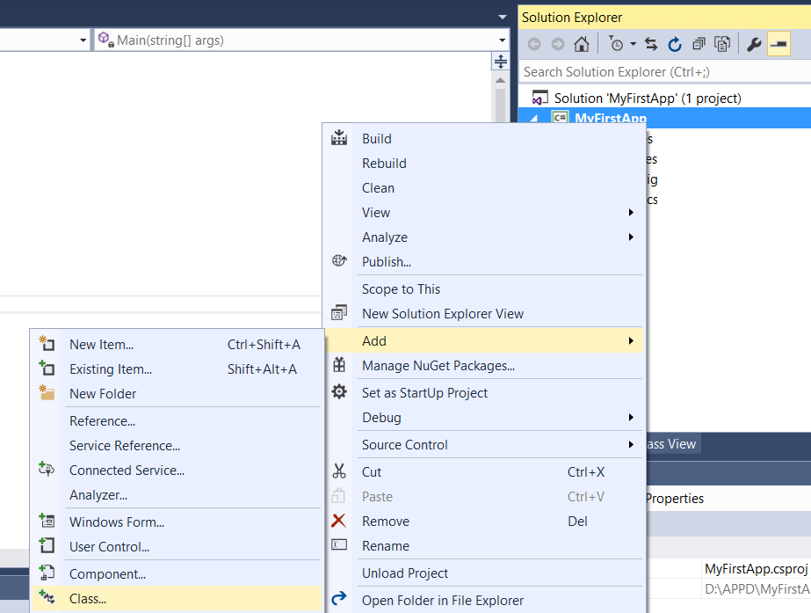

The Rectangle class consists of the following:

- 2 fields (instance variables) called m_width and m_height of type double.
- A default constructor to initialize m_width and m_height to 5 and 6.
- A parameterized constructor (overloaded) to initialize m_width and m_height using the values passed in.
- Accessors and Mutators (getters and setters) methods for m_width and m_height.
- A method called computeArea() that computes returns the area of the rectangle using the following formula.
Area = Width x Height

- A method called computePerimeter() that computes returns the perimeter value of the rectangle using the following formula.
Perimeter = (Width + Height) x 2

    - Open Program.cs (the class with main method) in the Solution Explorer. Add in the following codes for the main method to test your Rectangle class.
static void Main(string[] args)
{
Rectangle r1 = new Rectangle();
Rectangle r2 = new Rectangle(2,5);

Console.Write("r1's area: ");
Console.WriteLine(r1.computeArea());
Console.Write("r1's perimeter : ");
Console.WriteLine(r1.computePerimeter());

Console.Write("\nr2's area: ");
Console.WriteLine(r2.computeArea());
Console.Write("r2's perimeter : ");
Console.WriteLine(r2.computePerimeter());

r1.setHeight(2);
r1.setWidth(3);
Console.Write("\nr1's new height: ");
Console.WriteLine(r1.getHeight());
Console.Write("r1's new width: ");
Console.WriteLine(r1.getWidth());
Console.Write("\nr1's new area: ");
Console.WriteLine(r1.computeArea());
Console.Write("r1's new perimeter : ");
Console.WriteLine(r1.computePerimeter());

Console.ReadKey();
}

2.
- Replace all getters and setters in the Rectangle class with Properties. Note that the names of the properties are Width and Height.
- Modify the codes in Program.cs so that the program can run and generate the same output without any errors.

3.
- Create a new Console Application project and add a new class called Circle. The class consists of the following:
- A field (an instance variable) called m_radius of type double.
- A default constructor to initialize m_radius to 1.
- A parameterized constructor (overloaded) to initialize m_radius using the value passed in.
- Radius property to provide access to m_radius field from another class.
- A method called upsize() such that the circle’s radius will be doubled.
- A method called computeArea() that computes returns the area of the rectangle using the following formula.
Area = π x radius²

- Open Program.cs (the class with main method) in the Solution Explorer. Provide the codes for the following:
- Create an instance of Circle named circle1 with radius of 4 (using parameterized constructor).
- Create another instance of Circle named circle2 using the default constructor.
- Display the areas of both circles
- Upsize circle1 using upsize() method.
- Set the radius value for circle2 to 5.4.
- Display the areas of both circles again.
Your output should resemble the following: 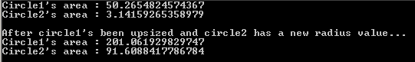

- END -

